**ASSIGNMENT – 2 (09/07/2024)**

1. **AREA OF QUADRATIC FUNCTION:**

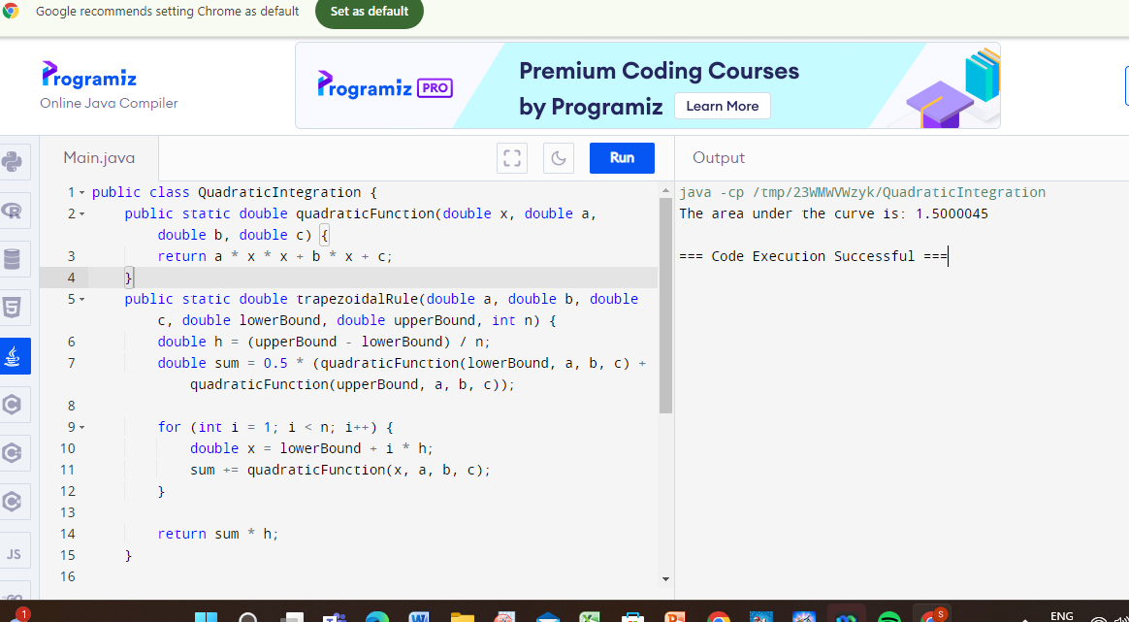

1. **FACTORIAL OF A NUMBER:**

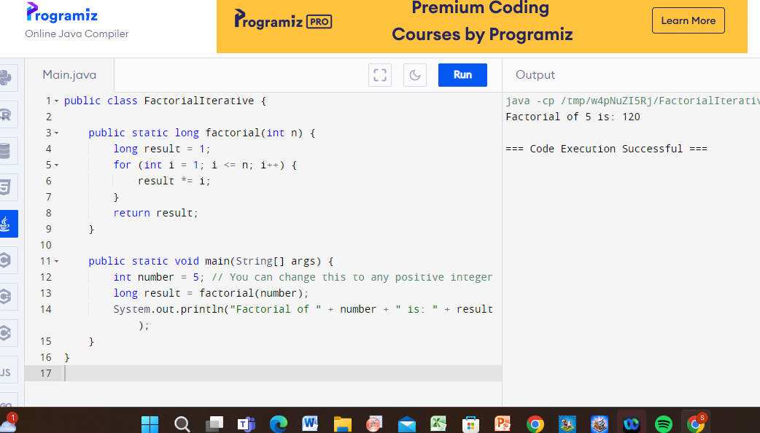

1. **SUM OF NUMBER USING FOR LOOP:**

